# CS 255 System Design Document

## UML Diagrams

### UML Use Case Diagram

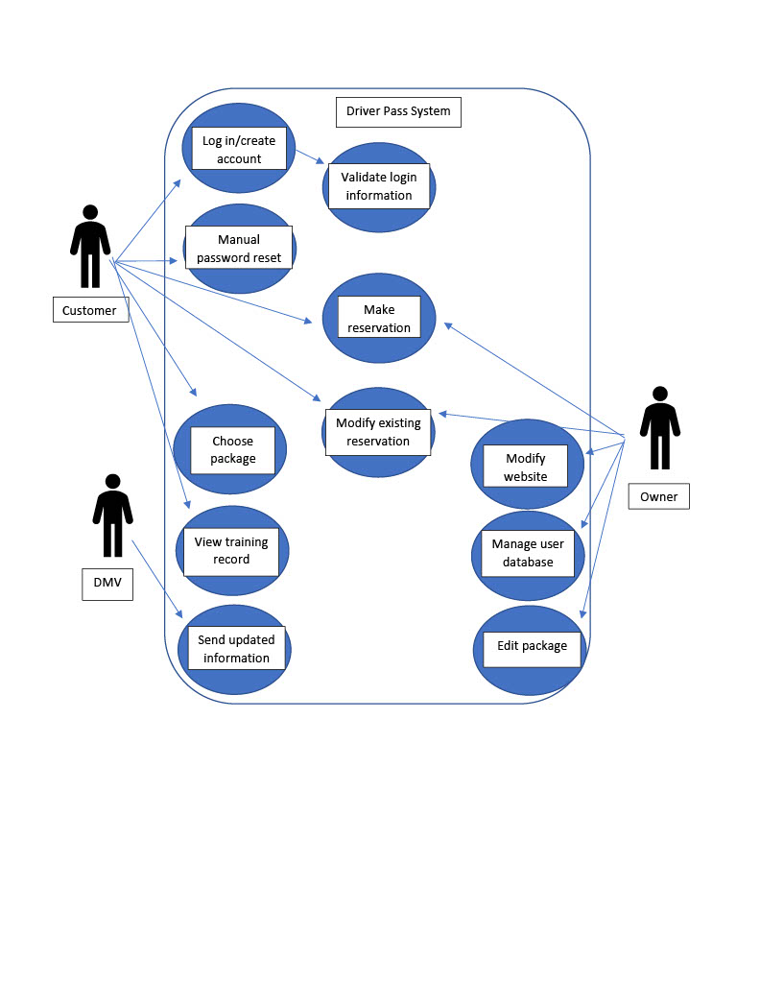

### UML Activity Diagrams

### UML Activity Diagrams

2

1

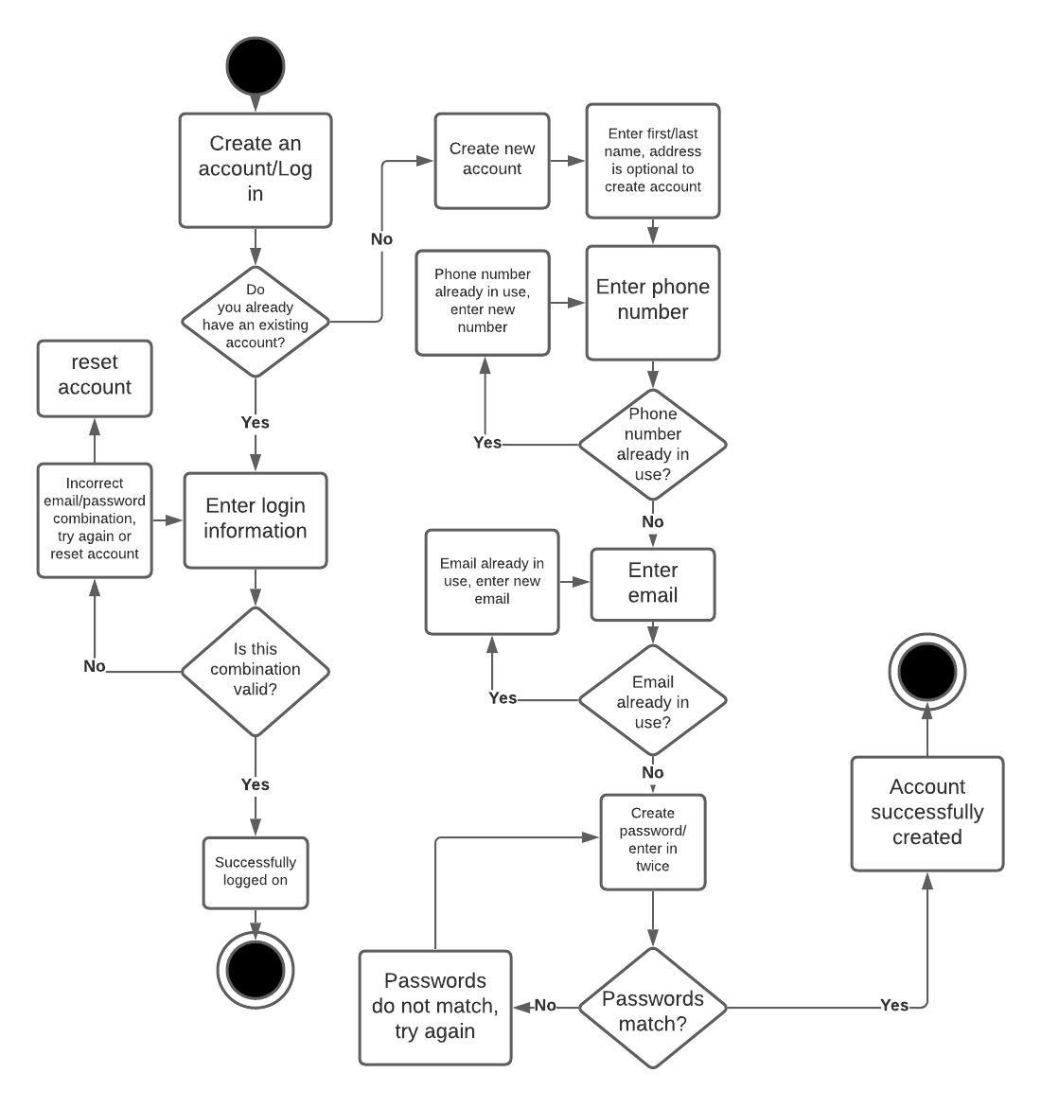

### UML Sequence Diagram

### UML Sequence Diagram

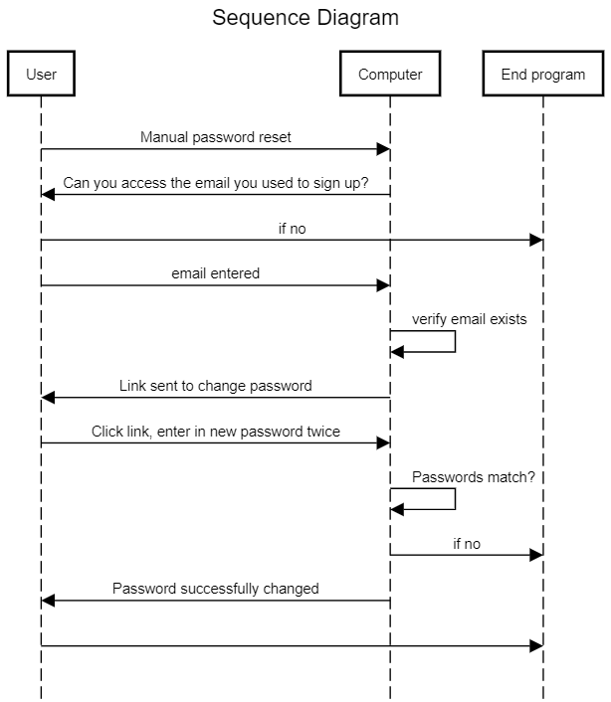

### UML Class Diagram

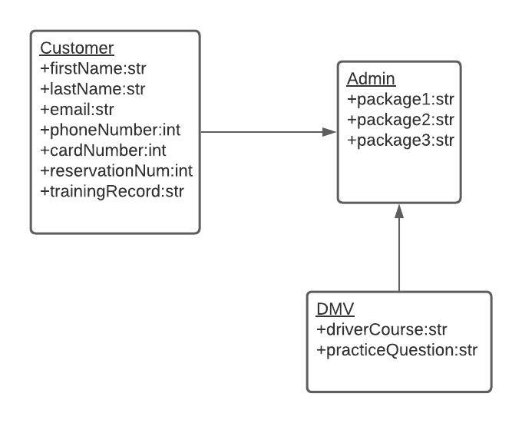

## Technical Requirements

This program should be web-based, over the cloud. It should run smoothly and on most common platforms, with windows preferred. Admins need to be alerted when DMV has an update, therefore the program must have a connection with their page. Updates will be scheduled in advance and performed after-hours to avoid inconvenience to customer. Data should be accessible on and offline, but as view only. Roles and rights are required for different users, reports should be downloadable and printable. Customers may choose a package, and admins can disable or edit packages. Interface shall be as described by customer.